H.T No
Regulations:
A18

Sreenidhi Institute of Science and Technology
(An Autonomous Institution)
Code No: 7BC03 Date: 01-Nov-2021 (FN)

B.Tech I-Year I- Semester External Examination, Oct/Nov-2021 (Supplementary)
ENGINEERING MECHANICS (ME)

Time: 3 Hours Max.Marks:70

Note: a) No additional answer sheets will be provided.
b) All sub-parts of a question must be answered at one place only, otherwise it will not be valued.
c) Missing data can be assumed suitably.

ANSWER ANY 5 OUT OF 8 QUESTIONS. EACH QUESTION CARRIES 14 MARKS.

Bloom's Cognitive Levels of Learning (BCLL)

Remember | L1 | Apply | L3 | Evaluate | L5
Understand | L2 | Analyze | L4 | Create | L6

 |  |  | BCLL | CO(s) | Marks
1. |  | A system of loads acting on a beam is shown in Fig. Determine the resultant of the loads.  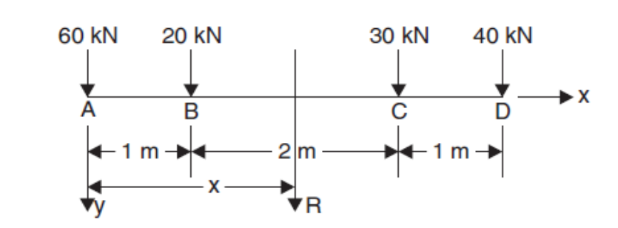  Fig. | L5 | CO1 | [14M]
2. | a) | Determine the forces in all the members of the trusses shown in Fig.  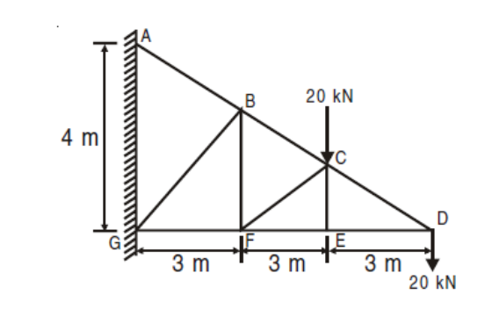Fig. | L5 | CO2 | [7M]
 | b) | Differentiate between perfect, deficient and redundant trusses. | L5 | CO2 | [7M]
3. |  | Locate the centroid of the triangle along h from the base.  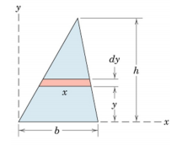 | L5 | CO3 | [14M]
4. |  | The cross-section of a rectangular hollow beam is as shown in Fig.. Determine the polar moment of inertia of the section about centroidal axes.  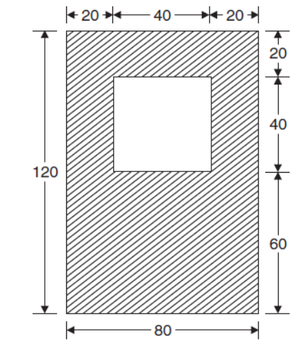Fig. | L5 | CO4 | [14M]
5. | a) | A body falling freely, under the action of gravity passes two points 10 metres apart vertically in 0.2 second. From what height, above the higher point, did it start to fall ? | L3 | CO5 | [7M]
 | b) | A train, starting from rest, is uniformly accelerated. The acceleration at any instant is , where (v) is the velocity of the train in m/s at the instant. Find the distance, in which the train will attain a velocity of 35 km.p.h | L3 | CO5 | [7M]
6. | a) | A train of mass 150 tonnes moves on a level track with a speed of 20 m/s. The tractive resistance is 100 newtons per tonne. Determine the power of the engine to maintain this speed. Also determine the power of the engine, when the train is to move with an acceleration of 0·3 on a level track. | L5 | CO6 | [7M]
 | b) | From a point, on a smooth floor of a room, a toy ball is shot to hit a wall. The ball then returns back to the point of projection. If the time taken by the ball in returning is twice the time taken in reaching the wall, find the coefficient of restitution between the ball and the wall. | L3 | CO6 | [7M]
7. | a) | What do you mean by coplanar concurrent force system? Explain with suitable example. | L2 | CO1 | [5M]
 | b) | The rotation of a fly wheel is governed by the relation α=10t−t² where α is in radians/s² and t is in seconds. How many revolutions will the flywheel make, starting from rest, before it momentarily stops prior to reversing its direction? | L3 | CO2 | [5M]
 | c) | An object of weight 100 N is kept in position on a plane inclined 30° to the horizontal by a horizontally applied force (F). If the coefficient of friction of the surface of the inclined plane is 0.25, determine the minimum magnitude of the force (F). | L5 | CO3 | [4M]
8. | a) | Find the moment of inertia of a T-section having flange and web both 120 mm × 30 mm about X-X axis passing through the centre of gravity of the section. | L5 | CO4 | [5M]
 | b) | A stone is thrown upwards from the top of a tower 70 m high with a velocity of 19.2 m/s. Determine its position and velocity when t = 6 secs. | L3 | CO5 | [5M]
 | c) | Explain Elastic Impacts and type of Impacts. | L2 | CO6 | [4M]

-- 00 -- 00 –

